

Synopsis Of

Internship Project

On

**“Cloud Storage *“***

***Submitted by***

*Ankit Suvarna*

*Akshat Shetty*

*Bhuvan Shetty*

***Under the supervision of***

Mr. Vijay G H

Architect

DLithe EdTech Company

**Abstract**

The concept of cloud computing becomes more and more popular in latest years. Data storage is very important and

valuable research field in cloud computing.

The concept of cloud computing becomes more and more popular in latest years. Data storage is very important and

valuable research field in cloud computing.

The concept of cloud computing becomes more and more popular in latest years. Data storage is very important and

valuable research field in cloud computing

The concept of cloud computing becomes more and more popular in latest years. Data storage is a very important and valuable research field in cloud computing

**Introduction**

Cloud Storage is a mode of computer data storage in which digital data is stored on servers in off-site locations. The servers are maintained by a third-party provider who is responsible for hosting, managing, and securing data stored on its infrastructure. The provider ensures that data on its servers is always accessible via public or private internet connections.

**Software Specification**

|  |  |
| --- | --- |
| Operating System | Windows 7 or above |
| Web Browser | Google Chrome, Microsoft Edge, or Opera |

**Methodology**

1. Front-end development languages used
2. Html

HTML (Hypertext Markup Language) is the code that is used to structure a web page and its content

1. CSS

Used for defining styles of the webpage

1. JavaScript

The code includes various JavaScript functions, which are mainly used for handling user interactions and performing specific tasks.

1. Back-end development
2. Firebase

The page includes scripts for Firebase authentication and database functionality, suggesting that the application might be using Firebase as a backend.

**Web Page Details**

1. Login page
2. First, we have to sign up and create our account

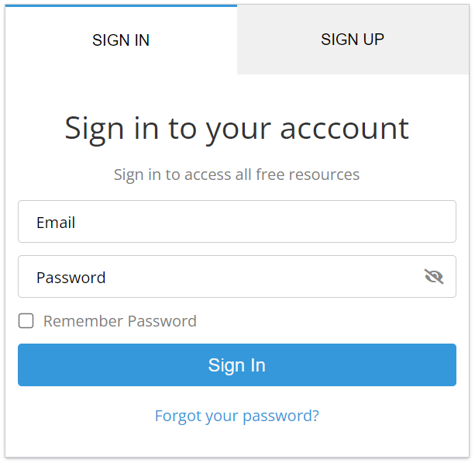

1. Once you have entered all your credentials your account will be created 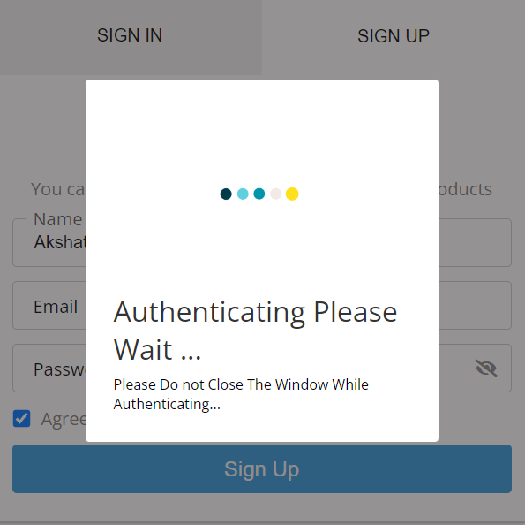
2. Home page

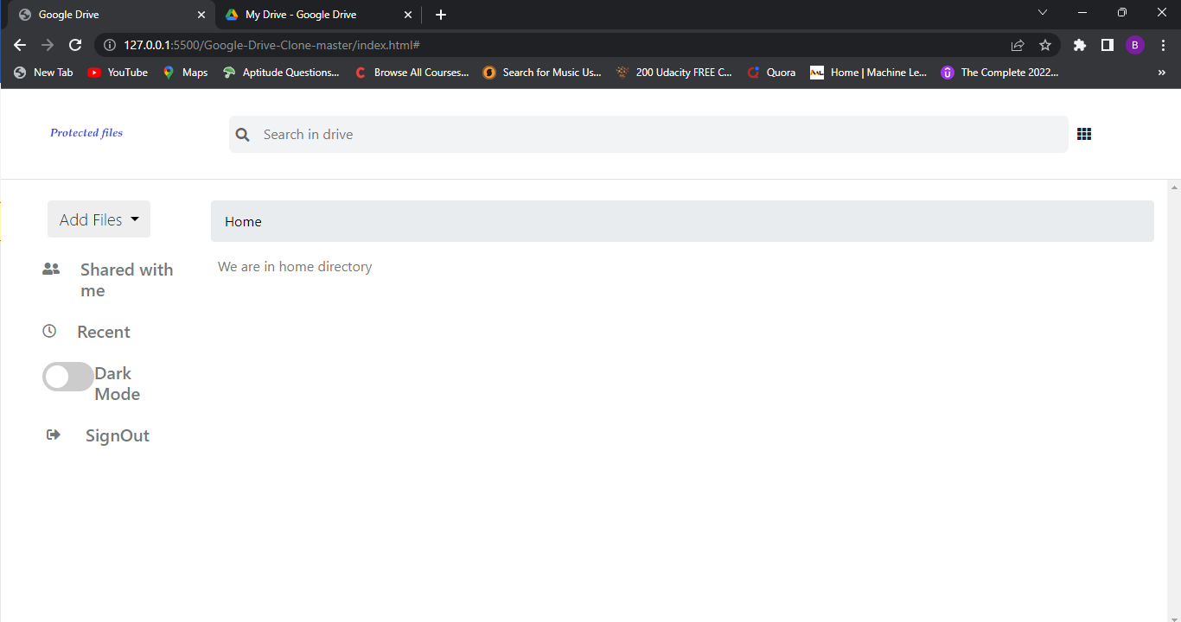

Therefore, we have dubbed this application "protected files," where we can upload whatever files or folders we desire.

1. Uploading File Process

i. First we have to clear here:

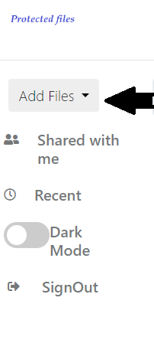

ii. Then it will ask from which folder to upload file

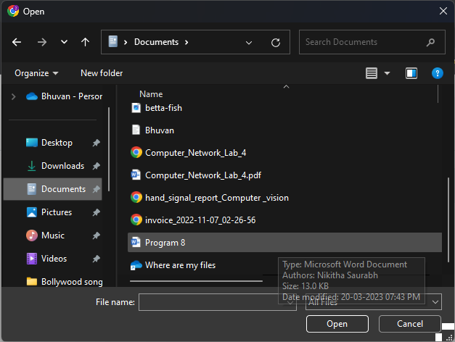

iii. After selecting we have to press open it will be uploaded

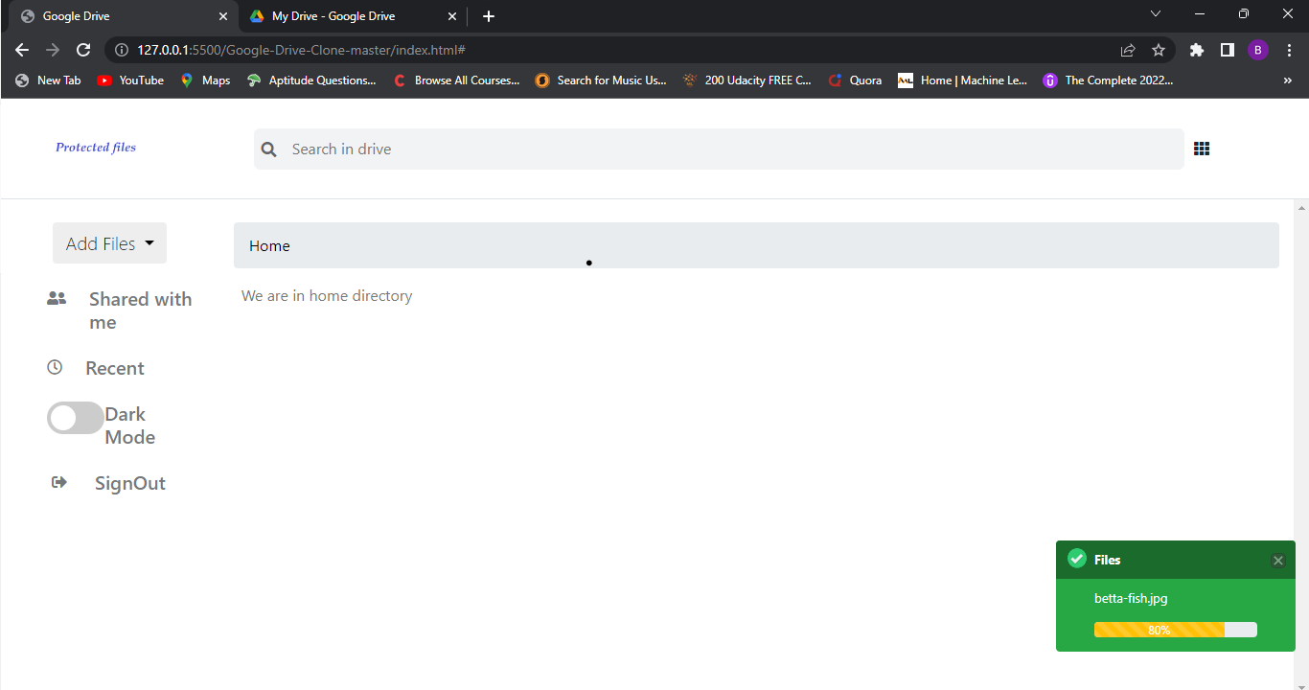

1. Uploaded file will be displayed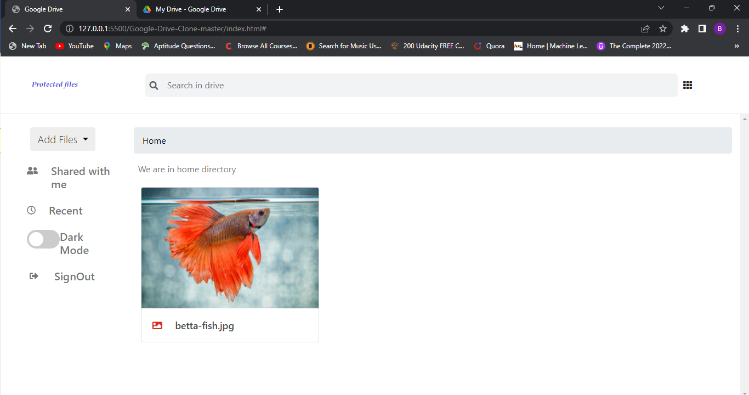

**Conclusion**

This application can be used in institutions like schools where students who are working on projects or practising something can upload it to the web application, download it to their device, and then work on the project if they are unable to finish it in the allotted time. We have an alternative web programme for that called Google Drive. To access Google Drive, we must sign in using our personal email address, and if we fail to log out, our personal data may be compromised.

Therefore, since the website only includes less sensitive files, we can log in there instead of using our personal email address to access it.